*Plan Revised June 1, 2021*

2021-2022

Parent and Family Engagement Policy for Shared Student Success

**Northeast Middle**

**School**

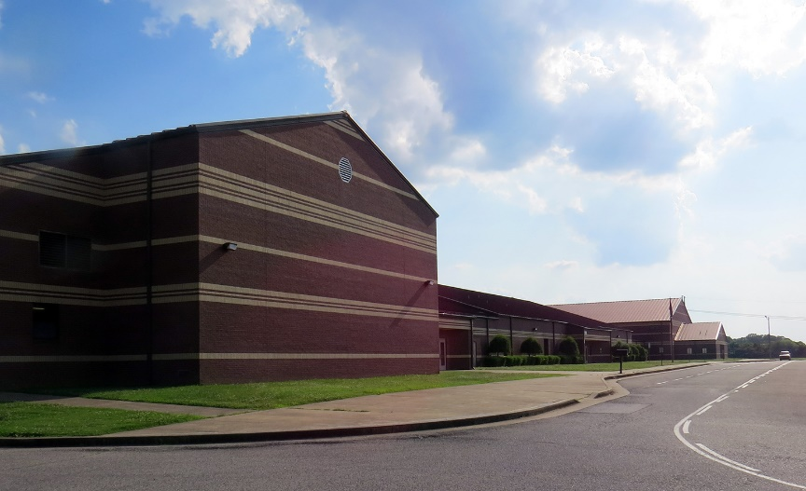

School Plan for Shared Student Achievement

#### What is it?

This is a plan that describes how Northeast Middle School will provide opportunities to improve family engagement to support student learning. Northeast Middle School values the contributions and involvement of families to establish an equal partnership for the common goal of improving student achievement. This plan describes the different ways that Northeast Middle will support family engagement and how families can help plan and participate in activities and events to promote student learning at school and at home.

#### How is it revised?

Family input and comments regarding this plan are welcome during the school year through an online form. The plan is posted on our school website for families to view and submit feedback throughout the year. All feedback received during the year will be used to revise the plan for the next school year. We also distribute an annual survey online and by mail to ask families for their suggestions on the plan and the use of funds for family engagement. Families can also give feedback during several meetings and activities during the school year.

#### Who is it for?

All students participating in the Title I, Part A program, and their families are encouraged and invited to fully participate in the opportunities described in this plan. Northeast Middle will provide full opportunity for the participation of parents and family members with limited English, with disabilities, and of migratory children.

#### Where is it available?

At the beginning of the year, the plan is posted on the school website and sent home with all students. Families can also retrieve a copy of the plan in the front office of the school.

#### What is Title I?

Northeast Middle is identified as a Title I school as part of the Every Student Succeeds Act (ESSA). Title I is designed to support state and local school reform efforts tied to the challenging state academic standards to improve teaching and learning for students. Title I programs must be based on effective means of improving student achievement and include strategies to support family engagement. All Title I schools must jointly develop with parents and family members a written parent and family engagement policy.

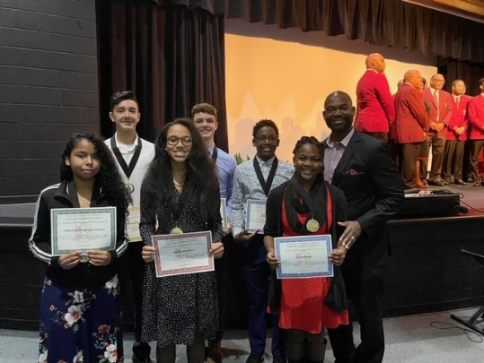

### 1B

**2B**

**When students, schools, families, and communities come together – we CAN achieve our goals!**

**1A**

#### Northeast Middle School

Michael B. Morris, Principal 2665 Christmasville Rd.

Jackson, TN 38301

(731)422-6877

<https://www.jmcss.org/northeast>

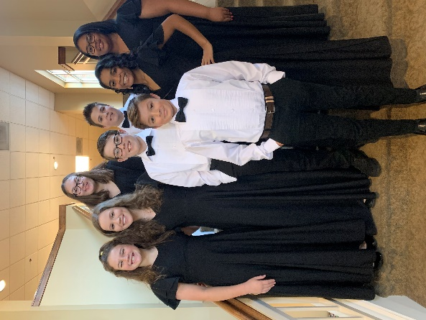

**2021-2022 Northeast Middle School Goals**

* Establish a safe, orderly, and productive learning environment.
* Increase reading and math achievement by 5%.

We have common expectations of our students. We want our *jaguars* to be **POWERful**!!

P- Punctual

O- Orderly

W- Work hard

E- Engaged

R- Respectful

**Parent and Family Engagement**

## Our mission is to encourage and challenge students to excel in a safe, nurturing, learning environment of high expectations and rigorous academics.

Opportunities to volunteer and participate in your child’s school:

* Assist in the library
* Volunteer to help at athletic events
* Assist with our school clubs
* Participate in our school Parent-Teacher-Organization

Each teacher may have specific needs that can be addressed through parent volunteers. Please contact your child’s teachers

to see how you can help or utilize your talents!

## School-Parent Compacts

The parents, students, and staff of Northeast Middle School developed this School-Parent Compact for achievement.

Teachers suggested home learning strategies, parents added ideas to make them more specific, and students told us

what would help them learn. Title I Site Committee meetings are held each year to review the compact and make

changes based on student needs.

* **Parents are welcome to contribute comments at any time.**
* **If you would like to *volunteer, participate*, and/or *observe* in the classroom,** please contact Michael Morris at mbmorris@jmcss.org

# Northeast Middle is branching out!

Northeast Middle will take the following measures to empower and support families as an important foundation in order to strengthen the school and reach our goals.

### 7A

We will:

#### Family Resources

**Come visit the school to check out books, study materials, and activities to use at home with your child. Computers are also available for parents to explore the Parent Portal and other educational resources.**

**Open Mon. – Fri., 7:00 a.m.-2:00 p.m. Ensure that all information related to school and family programs, meetings, and other activities is published on the school website and included in the monthly school newsletter for all families.**

Provide trainings for staff on strategies to improve communication with families and ideas to increase family engagement in reading and math for our students outside of the classroom.

Partner with early childhood programs, middle and high schools, college- and career-ready resources or organizations, parent resource centers, or other programs (as applicable) to help prepare parents and their children for successful school transitioning.

**7E**

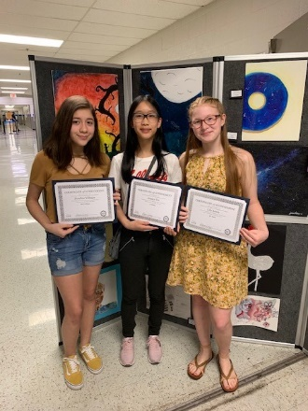

Assess students formally and informally throughout the year.

Our assessments will help us adjustment instruction to meet student needs.

Provide necessary materials and handouts for parents at conferences, meetings,

and activities to help parents work with their child to improve their child’s

achievement.

Use our Partners in Education and School Community Team to improve awareness

of the activities and events listed in the school parent and family engagement policy.

Use surveys to collect information from parents and students.

# Let’s get together!

Northeast Middle will host the following events to build the capacity for strong family engagement and support a partnership among the school, families, and the community to improve student academic achievement. Most meetings for parents and family members will be held twice during the day - in the morning before school and in the evening at 6:00 p.m. See the entire listing of events on our website.

#### Annual Title I Meeting – July 28, 2021 and July 29, 2021

We invite you to an evening of learning and sharing about our Title I program, including our parent and family engagement policy, the school-wide plan, and the school-parent compact. Invitations will be emailed and posted in the school newsletter and on social media.

#### Open House – July 28, 2021 and July 29, 2021

Meet your child’s teacher and learn about important grade level skills and standards that your child will be working on this year.

#### Parent-Teacher and Student Conferences – Sept. 2, 2021 & Feb. 17, 2022

Scheduled updates on your child’s progress.

#### Lunch ‘n Learn – 4 ½ week grading period, (TBD)

Bring a sack lunch and gain knowledge about topics relevant to your child’s education.

#### Community Cares Fair – (TBD)

Connect with the school and community to build a better school and review school plans.

#### Family Appreciation Celebration – (TBD)

A celebration of family engagement and the recognition of its impact on school and student success.

**Improvement Forum-(TBD) 2C**

A forum for parents and family members to participate in roundtable discussions with the principal and staff regarding the school-wide plan,

parent and family engagement policy, school-parent compacts, and the family engagement budget.

**Parent and Family Engagement Standards**

Northeast Middle School and our families have adopted the National PTA Standards for Family-School Partnerships as the school’s model in engaging parents, students, and the community. These standards are:

1. Welcoming All Families
2. Communicating Effectively
3. Supporting Student Success
4. Speaking Up for Every Child
5. Sharing Power
6. Collaborating with Community

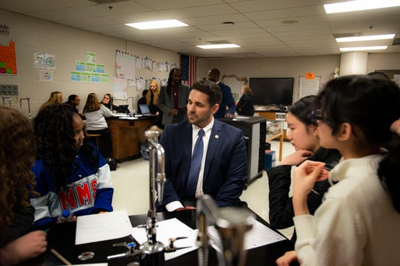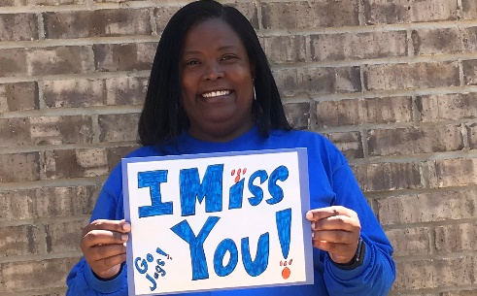

**School Community Team**

Northeast Middle invites all families to join the School Community Team to share ideas and ways to involve others to build partnerships with school, families, and the community. The team will meet four times during the school year, but parents and family members can also submit their ideas or suggestions at any school activities and meetings, as well as through our family surveys and website. If you would like to learn more about the School Community Team, please contact Michael Morris at (731) 422-6687 or complete the interest form below and leave it in the front office.

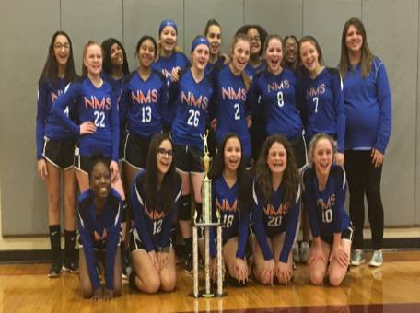

**Name:**

**Child’s Name and Grade Level: Address: Phone Number:**

**Email Address:**

**School Community Team**

Yes, I am interested and wish to join the School Community Team.

Please contact me so I can learn more about joining the School Community Team. Please send me notifications about future meetings and updates.

We want to hear from you! If you have any suggestions or if there is any part of this policy that you feel is not satisfactory with

the students’ and the school’s goals for academic achievement, please provide us with your comments in the space provided and leave this form in the front office:

**Name (optional): Phone Number (optional):**

**Comments:**

**Share Your Thoughts**